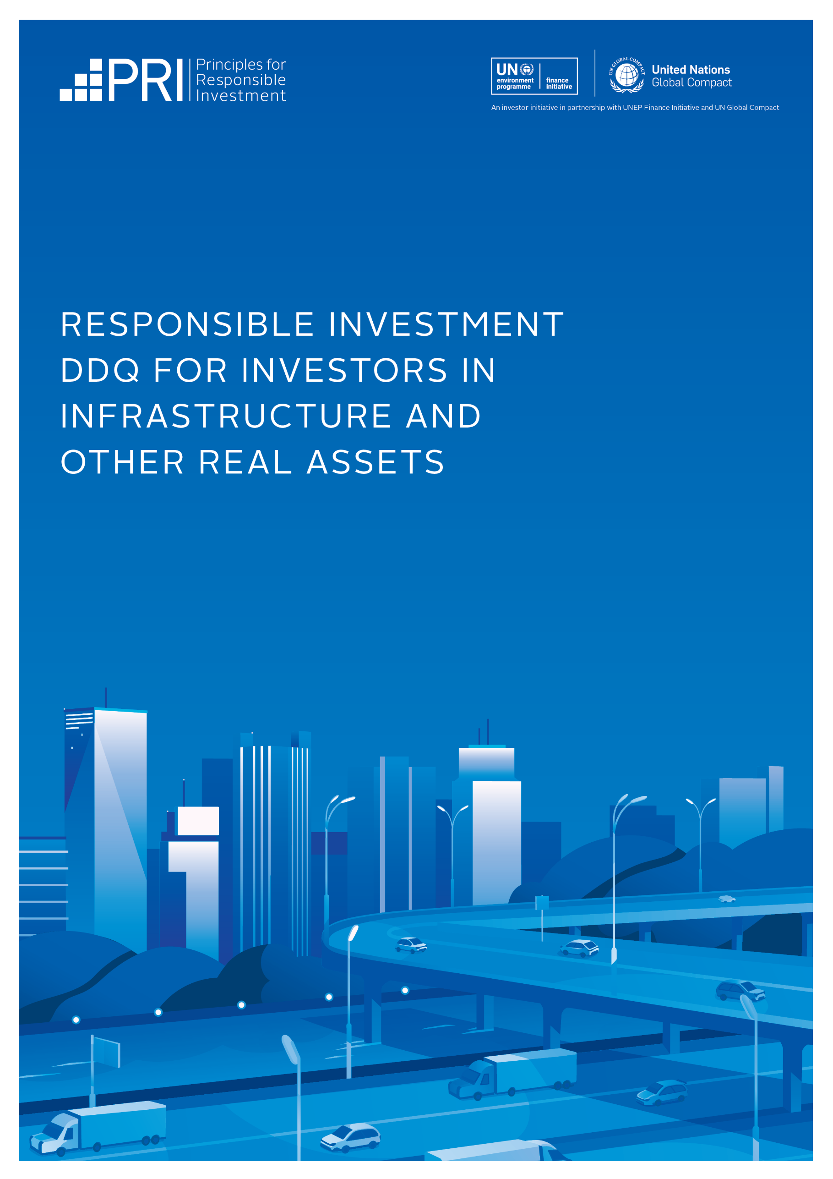

ABOUT THIS DDQ

Document Checklist
A suggested checklist of documents that investors can request from investment managers during the due diligence process.
This due diligence questionnaire (DDQ) has been developed to help investors better understand and evaluate investment managers’ approaches to responsible investment.  The questions in this DDQ are primarily tailored to investment managers who make direct investments in infrastructure, though the questions can be adapted for managers of forestry and farmland investments. When a question, or element of a question, is relevant to investors in forestry or farmland only, this is specified. There is a separate RI DDQ for real estate investors.  The DDQ should not be considered in isolation, but rather used to support a wider information-gathering process. The PRI encourages investors to:  - consider what additional resources are available to enhance their understanding of investment managers’ answers, and  - engage with investment managers to seek additional information and clarification, where necessary.  To promote consistency, the DDQ is designed to complement the information gathered through the PRI’s Reporting Framework – particularly the infrastructure module – as well as investment disclosure standards and frameworks developed by external organisations. The DDQ will be updated periodically to align with future changes to the Reporting Framework.  We have previously published a DDQ on diversity, equity and inclusion (DEI). Investors are invited to supplement these infrastructure-related questions with those in the DEI DDQ.  Please contact infrastructure@unpri.org if you have questions or feedback regarding this DDQ. | NOTES ON USING THIS DDQ  The appendix lists where questions in this DDQ map, either fully or partially, to indicators within the PRI 2024 Reporting & Assessment Framework and the GRESB 2024 Assessment.  Some questions in the DDQ focus on an organisation’s overarching approach to responsible investment, while others apply at the fund level.  The DDQ provides guidance on the type of information each question is aiming to elicit. The PRI encourages investment managers to answer the question in a way that goes beyond these points.  Where relevant, we refer to the Reporting Framework glossary of key terms.
Organisation-level responsible  investment documents | Fund-level responsible investment documents
- PRI transparency report  - Responsible investment policy  - Responsible investment reports  Impact investing report (relevant for allocators to impact strategies)  - Code of conduct  - DEI policy  - Whistleblower policy  - Task Force on Climate-Related Financial Disclosures (TCFD) report  Taskforce on Nature-related Financial Disclosures (TNFD) report | - Examples of environmental, social and governance (ESG) disclosures from fund(s) / investment vehicle(s) that a manager currently and / or previously managed  - Any additional policies relating to ESG matters

DDQ QUESTIONS

QUESTION | YES / NO |  | DESCRIPTION
POLICY, GOVERNANCE, COMMITMENTS AND RESOURCING
Questions in this section ask for information about the organisation-level approach to responsible investment.
1.1 Do you have a responsible investment policy? | Yes ☐  No ☐ |  | If yes, provide details below. State below whether it is publicly available (1.1.A); when it was published (1.1.B); how it is reviewed and updated (1.1.C). Briefly describe what the policy covers (1.1.D), stating whether it includes commitments on topics such as climate change, human rights, biodiversity, or DEI.  If your organisation does not have a responsible investment policy, or if the policy does not cover all investments, explain why not.
Answer here
1.2 Have you committed or contributed to any international standards, industry (association) guidelines, reporting frameworks, or initiatives that promote responsible investment practices? | Yes ☐  No ☐ |  | If yes, provide details below. Examples include being a PRI signatory, adhering to the UN Guiding Principles on Business and Human Rights, and committing to support the Sustainable Development Goals (SDGs).  For forestry investors: state whether your forestry holdings are certified by internationally-recognised bodies such as the FSC or PEFC. If so, state the percentage of your holdings covered by the certification and how long the certifications have been in place..
Answer here
1.3 Have you assigned (i) oversight responsibilities and (ii) implementation responsibilities for responsible investment within your organisation? | Yes ☐  No ☐ |  | If yes, provide details. List the persons involved, their role, tenure and position within the organisation and how they are qualified for this role (1.3.A). Also mention any relevant responsibilities held by committees (eg investment, sustainability committees (or equivalents)) and covered by their governance arrangements (1.3.B). Describe any external resources you use (1.3.C).
Answer here

1.4 Does your organisation ensure its investment professionals and other relevant staff are trained on responsible investment and stay up-to-date on applicable topics? | Yes ☐  No ☐ |  | If you provide training, assistance and / or additional resources, provide details. Describe what they cover (1.4.A), which staff receive them (1.4.B) and how frequently they are delivered (1.4.C)
Answer here
1.5 Does your organisation incorporate RI-related key performance indicators (KPIs) into performance reviews and compensation mechanisms for employees? | Yes ☐  No ☐ |  | If yes, provide details. Describe how KPIs are defined and measured (1.5.A) and to which positions they apply, e.g., investment professionals, ESG / sustainability teams, senior management etc (1.5.B).
Answer here
1.6Do you make, or plan to make, formal responsible investment commitments in documents such as Limited Partnership Agreement(s), side letters, or other constitutive fund documents? | Yes ☐  No ☐ |  | If yes, describe these and, where possible, share sections of your private placement memorandum or other relevant materials. Examples may include net-zero commitments and commitments to conduct ESG integration.
Answer here
PRE-INVESTMENT
Questions in this section ask for information on the investment strategy that’s being assessed.
2.1 Do you have a formal exclusion policy based on ESG factors? | Yes ☐  No ☐ |  | If yes, provide details. Also mention whether you can apply LP-directed exclusions or screens (for example, as agreed in side letters).
Answer here

2.2 Do you identify, conduct due diligence and engage on ESG factors for potential investments? | Yes ☐  No ☐ |  | If yes, describe and provide examples of the process, including any tools, standards, and data used to identify and assess ESG risks and opportunities for each investment. Mention the level(s) at which the analysis is conducted (e.g., individual assets, sector-level) (2.2.A). State whether you conduct scenario analysis in relation to ESG factors, including details of what scenarios are used (2.2.B).  Describe and provide examples of your approach to supply chain risk analysis and responsible procurement practices (2.2.C).  Describe and provide examples of how you identify and engage with key stakeholders (2.2.D).
Answer here
2.3 Do ESG factors affect investment selection? | Yes ☐  No ☐ |  | If yes, describe how. Mention whether they lead to abandoning certain investments, impact their valuation, or affect other deal terms (2.3.A). State whether your investment committee or equivalent decision-making body considers material ESG factors (2.3.B).  If not covered by the above, please explain how climate-related risks and opportunities affect your investment strategy or investment selection (2.3.C).
Answer here
2.4 During deal structuring, do you integrate ESG-related considerations into transaction documentation? | Yes ☐  No ☐ |  | If yes, describe the process, including any ESG-related representations made when acquiring an asset. Illustrate the process with a recent example.
Answer here
SELECTION, APPOINTMENT AND MONITORING OF THIRD-PARTY OPERATORS
Questions in this section ask for information on the investment strategy that’s being assessed.
3.1 Do you include ESG factors in your selection, appointment and monitoring of third-party operators / managers, if applicable? | Yes ☐  No ☐  N/A ☐ |  | If yes, describe the approach. Mention whether you assess ESG policies, responsible procurement and / or contractor practices, ESG track records, and examples of ESG initiatives during selection (3.1.A); include ESG clauses in asset or project management contracts (3.1.B); set targets (and incentives related to these targets) on ESG factors to monitor performance against (3.1.C); set ESG reporting requirements, such as for ESG incidents (3.1.D).
Answer here
POST-INVESTMENT
Questions in this section ask for information on the investment strategy that’s being assessed.
4.1 Do you / your third-party operators / managers track and use KPIs relating to ESG factors for your investments? | Yes ☐  No ☐ |  | If yes, explain how you identify these KPIs, including any frameworks used. Provide examples of the KPIs tracked (e.g., energy consumption, water consumption, waste production, biodiversity conservation, soil health, community impact, worker safety and labour practices) and specify the proportion of assets or portfolio companies covered. Provide examples of how you set targets or benchmark performance against, for example, comparable assets, funds, companies or transition pathways.  In addition, please include any KPIs related to climate change risks and opportunities.
Answer here
4.2 Do you manage ESG risks and opportunities to protect and create value during the holding period? | Yes ☐  No ☐ |  | If yes, provide details. Describe how you develop and implement ESG action plans, and how these vary depending on whether you take a minority or majority investment. Provide recent examples of actions taken (4.2.A).  Provide examples of relevant measures you use to influence the management of ESG factors in each of your portfolio companies / assets, such as using board seats or engagement with boards of portfolio companies / assets to ensure that ESG factors are addressed, engaging with co-investors to align on how ESG factors are addressed, and seeking to link ESG objectives / performance to compensation mechanisms at the portfolio company / asset level. Ensure that any relevant discussion around the management of climate-related risks and opportunities is also included (4.2.B).  Provide details and examples of your approach to engaging with key stakeholders for each investment, particularly where required to ensure the successful integration of projects within local communities and to support obtaining and retaining necessary operating licences. This may include details of specific actions and strategies your organisation employs to address issues such as community engagement, environmental impact, customary land tenure rights, human rights standards, equitable benefit sharing, conflict resolution, preservation of cultural heritage, and long-term community development (4.2.C).
Answer here
4.3 Do you have ESG requirements for new / development projects? | Yes ☐  No ☐  N/A ☐ |  | If yes, provide details. Requirements may relate to the use of sustainable building materials; air quality protection during construction; engaging with stakeholders, including local communities; and best practice health and safety standards.
Answer here

4.4 Do you ensure that ESG-related competence and resources exist at the asset or portfolio company level? | Yes ☐  No ☐ |  | If yes, explain the approach. Provide examples of relevant initiatives such as training (and who it is targeted at), supporting knowledge sharing across portfolio companies / assets, and providing human and financial resources, as appropriate, to support ESG programmes.
Answer here
4.5 Do you assess financial outcomes in the investment lifecycle related to ESG incorporation? | Yes ☐  No ☐ |  | If yes, explain the approach. Provide one or two recent examples, describing how you assessed financial outcomes in the investment lifecycle related to ESG incorporation.  If you do not measure the financial implications of your ESG incorporation activity, provide details on when / if you expect to do so, and what tools / methodologies you are exploring.
Answer here
4.6 Do ESG factors impact your exit preparations? | Yes ☐  No ☐ |  | If yes, explain how and provide relevant examples, such as how ESG factors may influence decisions on prices asked for and the types of potential buyers you seek, as well as the information you share with buyers (e.g., RI approach, outcomes of asset or project ESG risk assessments, asset ESG performance data).
Answer here
SUSTAINABILITY OUTCOMES
Questions in this section ask for information on the investment strategy that’s being assessed.
5.1 Do you identify sustainability outcomes related to this investment strategy / fund , for example relating to biodiversity or human rights? | Yes ☐  No ☐  N/A ☐ |  | If yes, describe the approach. Disclose any frameworks or tools you use to do so (e.g., the SDGs, the Paris Agreement, the Global Biodiversity Framework). Provide recent examples of the positive or negative outcomes that you have identified (e.g., the impact of the investments on ESG issues such as climate change, biodiversity and human rights). If ‘no’ or ‘N/A’, please explain why you do not identify sustainability outcomes.
Answer here
5.2 Do you take action to improve the sustainability outcomes connected to investments? | Yes ☐  No ☐  N/A ☐ |  | If yes, provide details and recent examples of actions taken by portfolio companies at your request. Mention the sustainability outcomes objectives targeted and the actions taken to intentionally increase positive and / or decrease negative sustainability outcomes. Activities may include capital allocation or investment decisionmaking and stewardship with portfolio companies / assets, policy makers and other key stakeholders. If ‘no’ or ‘N/A’, please explain why you do not take action to improve sustainability outcomes.
Answer here
CLIMATE
Questions in this section ask for information on the investment strategy that’s being assessed.
6.1 Do you measure and report the greenhouse gas (GHG) emissions associated with your investments? | Yes ☐  No ☐ |  | If yes, describe the methodology used. If you do not measure and report GHG emissions, please explain why, or the current status of your efforts
Answer here
6.2 Have you set any climate / emissions-related KPIs and targets as a firm and / or in your portfolio companies? | Yes ☐  No ☐ |  | If yes, provide details. Describe any climate- / emissions-related KPIs and targets you have set with your portfolio companies or committed to as a firm (6.2.A). If this strategy has a net-zero GHG emissions objective, please specify this and provide details (6.2.B). (Ensure that, if relevant, you have responded to the guidance on climate-related risks and opportunities in previous questions, and add any further discussion that may be relevant here.)
Answer here
6.3 Do you integrate climate adaptation and resilience considerations into your investments? |  | Yes ☐  No ☐ |  | If yes, please describe the processes, methodologies, and tools employed to identify and mitigate potential climate-related risks, including the frequency of these assessments. Explain how the outcomes of these assessments are incorporated into both your investment decision-making process and ongoing management strategies (6.3.A). Where available, provide details on the main risks you are exposed to and any related financial metrics (6.3.B).
Answer here
DISCLOSURES
The questions in this section ask for information on the investment strategy that’s being assessed.
7.1 Do you disclose information on your responsible investment activities and performance to investors? |  | Yes ☐  No ☐ |  | If yes, provide details. Describe how the information is disclosed (e.g., in meetings with investors, written disclosures), the frequency of reporting and whether disclosures are linked to specific frameworks (e.g., the PRI Reporting Framework, the TCFD recommendations, GRESB).  Provide examples of specific metrics disclosed (e.g., weighted average carbon intensity, carbon footprint) and the proportion of assets or projects covered. Provide recent examples of ESG-related disclosures (7.1.A).  State whether the management of ESG risks and opportunities is included on your Limited Partners Advisory Committee and Annual Investor Meeting agenda. Provide one or two examples of included issues at the portfolio company / asset or fund level (7.1.B).
Answer here
7.2 Do you disclose material ESG incidents to investors? |  | Yes ☐  No ☐ |  | If yes, describe any processes you use to report material ESG incidents. Provide details of how you assess what may constitute a material ESG incident, e.g., those with legal implications or resulting in an insurance claim over a certain amount.
Answer here
ADDITIONAL INFORMATION
8.1 Is there any information on your organisation’s RI approach, not otherwise covered in the DDQ, that you would like to share?

Answer here

APPENDIX: INDICATOR MAPPING
10

The questions in this DDQ map, either fully or partially, to the following indicators within the PRI 2024 Reporting & Assessment Framework and the GRESB 2024 Assessment.

Due diligence questions | 2024 PRI  Reporting & Assessment Framework indicator(s) | GRESB
POLICY, GOVERNANCE, COMMITMENTS AND RESOURCING
1.1 Do you have a responsible investment policy? | PGS 1, 3, 8  INF 1 | PO 1, PO 2, PO 3, LE 3
1.2 Have you committed or contributed to any international standards, industry (association) guidelines, reporting frameworks, or initiatives that promote responsible investment practices? | PGS 17, 18  SLS 1 | LE 2, CA 1
1.3 Have you assigned (i) oversight responsibilities and (ii) implementation responsibilities for responsible investment within your organisation? | PGS 11, 11.1, 12 | LE 4, 5
1.4 Does your organisation ensure its investment professionals and other relevant staff are trained on responsible investment and stay up to date on applicable topics? | PGS 15 | EM 1
1.5 Does your organisation incorporate RI-related key performance indicators (KPIs) into performance reviews and compensation mechanisms for employees? | PGS 13, 14 | LE 6
1.6 Do you make, or plan to make, formal responsible investment commitments in documents such as Limited Partnership Agreement(s), side letters, or other constitutive fund documents? | INF 2
PRE-INVESTMENT
2.1 Do you have a formal exclusion policy based on ESG factors? | PGS 1, 3, 11.1, 20, INF 1
2.2 Do you identify, conduct due diligence and engage on ESG factors for potential investments? | PGS 41, 43  INF 3, 3.1, 5 | RM 2.1, RM 2.2, RM 2.3, RM 4.1, RM 4.2, RM 4.3, RM 4.4,  RM 4.5, SE 1, SE 2, SE 3.2
2.3 Do ESG factors affect investment selection? | PGS 41.1  INF 4
2.4 During deal structuring, do you integrate ESG-related considerations into transaction documentation? | INF 2, 16
SELECTION, APPOINTMENT AND MONITORING OF THIRD-PARTY OPERATORS
3.1 Do you include ESG factors in your selection, appointment and monitoring of third-party operators / managers, if applicable? | INF 6, 7, 8

POST-INVESTMENT
4.1 Do you / your third-party operators / managers track and use KPIs relating to ESG factors for your investments? | INF 8, 9, 10  SO 2, 3 | RM 5.1, RM 5.2, RM 5.3, AP 1, WT 1, WT 2, WS 1, HS 1, HS 2, HS 3, HS 4
4.2 Do you manage ESG risks and opportunities to protect and create value during the holding period? | PGS 44, 45  INF 11, 13, 14, 15 | RM 1, RM 3, RM 4.5, SE 1, SE 3.1, IM 1, IM 2, IM 3
4.3 Do you have ESG requirements for new / development projects?
4.4 Do you ensure that ESG-related competence and resources exist at the asset or portfolio company level? | INF 14
4.5 Do you assess financial outcomes in the investment lifecycle related to ESG incorporation? | INF 4, 11
4.6 Do ESG factors impact your exit preparations? | INF 16
SUSTAINABILITY OUTCOMES
5.1 Do you identify sustainability outcomes related to this investment strategy / fund, for example relating to biodiversity or human rights? | PGS 47, 47.1, 47.2 | GH 1, AP 1, WT 1, WT 2, WS 1, HS 1, HS 2, HS 3, HS 4  BI 1
5.2 Do you take action to improve the sustainability outcomes connected to investments? | PGS 48, 48.1  SO 1, 2, 2.1, 3.3, 4,  4.1, 5, 6, 7 | IM 1, IM 2, IM 3
CLIMATE
6.1 Do you measure and report the greenhouse gas (GHG) emissions associated with your investments? | PGS 46 | RM 5.1, EN 1, GH 1
6.2 Have you set any climate / emissions-related KPIs and targets as a firm and / or in your portfolio companies? | SO 1, 2, 2.1, 3
6.3 Do you integrate climate adaptation and resilience considerations into your investments? | PGS 41, 43, 45 | RM 3, RM 4.1, RM 4.2, RM 4.3, RM 4.4, RM 4.5, RM 4.6
DISCLOSURE
7.1 Do you disclose information on your responsible investment activities and performance to investors? | INF 17 | RP 1, EM 2
7.2 Do you disclose material ESG incidents to investors? | INF 17 | RP 2.1

